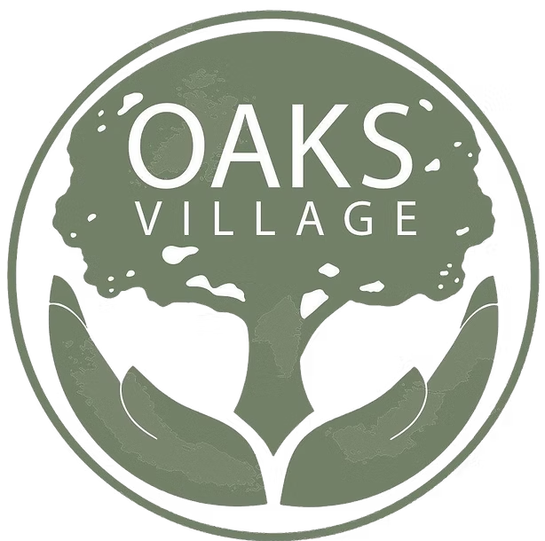
OAKS VILLAGE
Community Sponsorship Levels
"A Hand Up — Not A Hand Out"

Your investment helps restore lives and rebuild families in Monroe, Michigan. Join us as a Community Sponsor and become a visible partner in our mission.
$1,000 — Friend of the Village

- Name/logo recognition in a dedicated Facebook sponsor appreciation post (organic reach to 9,900+ local followers)
- Listed as a sponsor on the Oaks Village Facebook page
- Certificate of appreciation from Oaks Village leadership

$2,500 — Neighbor Level

- Everything at Friend of the Village, plus:
- Name/logo featured on the Oaks Village website (Sponsors/Partners page)
- Oaks Village branded hoodie or t-shirt
- Tagged in a dedicated impact post showing what your gift made possible

$5,000 — Pillar of the Community

- Everything at Neighbor level, plus:
- Invitation to host a table at our re-opening event
- Recognition in printed materials (event programs, flyers) produced during the sponsorship year

$10,000+ — Cornerstone Sponsor

- Everything at Pillar level, plus:
- Named plaque on the wall for the year of sponsorship at the shelter upon reopening
- Featured quote in an annual impact report or major campaign
- For donors at the $20,000+ level: Opportunity to sponsor and name a specific program element (e.g., "The [Company] Clothing Closet" or "Meals Provided by [Sponsor]") for the year

To become a sponsor, contact us:
(734) 244-5444 | chelsea.wade@oaksvillage.net | www.oaksvillage.net
924 E. 2nd Street, Monroe, MI 48161

